**Assignment No 1**

**By Muskan Choraria**

[**tamkor09@gmail.com**](mailto:tamkor09@gmail.com)

**Question no 1**

Machine learning is the art of programming abd coding by which a computer learns new things from the given data.

**For example:**

Let’s consider our human brain as a computer.

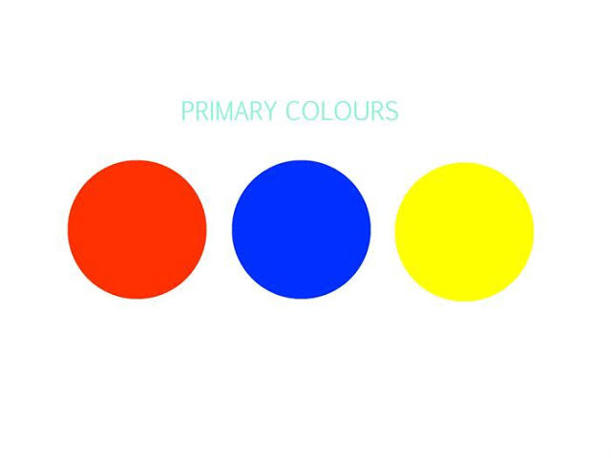

Throughout our lives, starting at home and school, we were taught of basic colours as these are given in the picture.

The colour are

* Red
* Blue
* Yellow

But what if I put a new set of Color’s in front of you

Just like the one given below:



This one is hex green or turquoise colour.



This is Cadbury purple colour.



This is the wild pink colour.

So,

All these 3 colours from set 2 are not known by all the people unlike the set 1 colours.

This is is what a machine does in 3 steps:

1. **It identifies what it is asked to identify or find out:** in this example, the computer was asked to identify the Colours in both the sets.
2. **Learn new things:** the computer identifies what it knows, like set 1 colours and learns what it didn’t and store it as new information, just like the set 2 colours.
3. **Accuracy of identifying:** it also keeps a check on the accuracy of the knowledge it already had stored and for the new one as well.

This helps in improvement of identification later.